МІНІСТЕРСТВО ОСВІТИ І НАУКИ УКРАЇНИ

ДЕРЖАВНИЙ УНІВЕРСИТЕТ ТЕЛЕКОМУНІКАЦІЙ

Навчально-науковий інститут інформаційних технологій

Лабораторна робота 7

з дисципліни

**«Якість програмного забезпечення та тестування»**

**Postman**

Виконав студент групи ПД-41  
Гапей Максим Юрійович

Київ – 2023

1. **Add new place into Server**

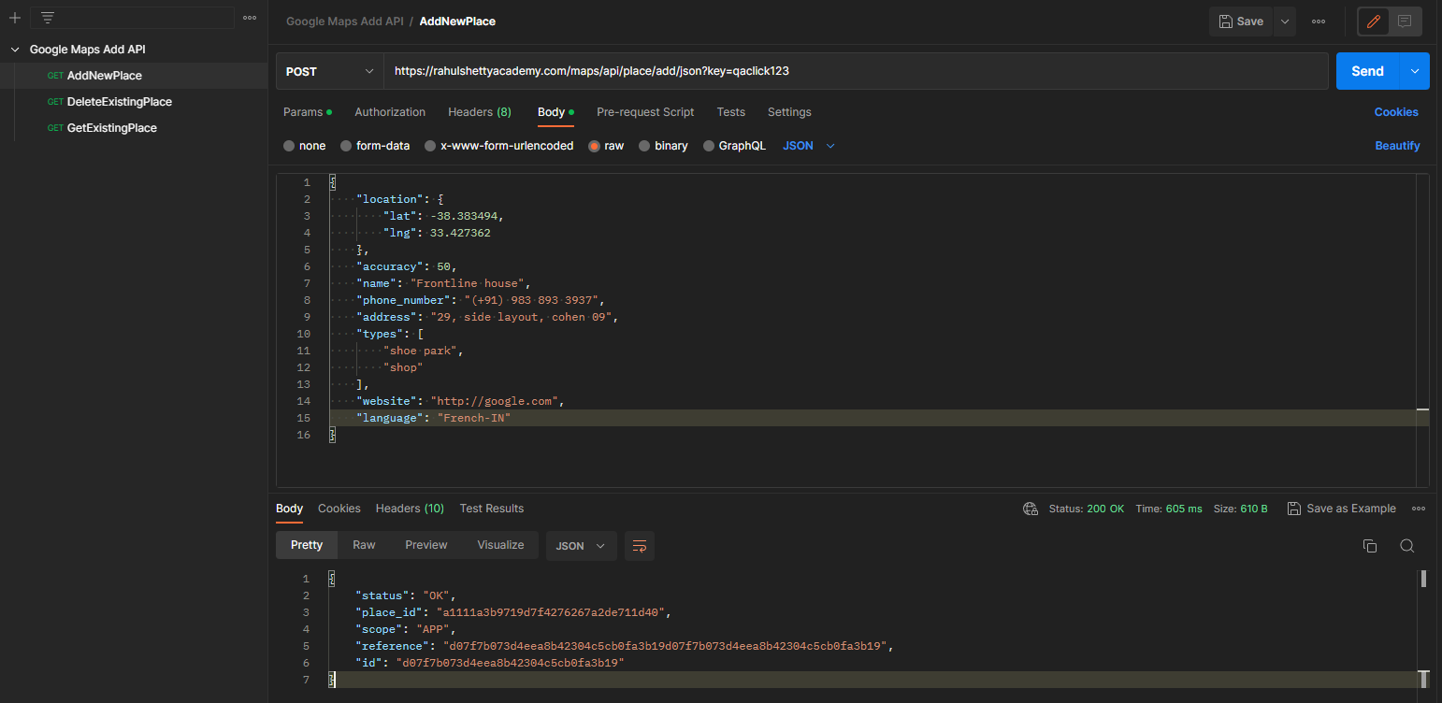  
Body:

{

"location": {

"lat": -38.383494,

"lng": 33.427362

},

"accuracy": 50,

"name": "Frontline house",

"phone_number": "(+91) 983 893 3937",

"address": "29, side layout, cohen 09",

"types": [

"shoe park",

"shop"

],

"website": "http://google.com",

"language": "French-IN"

}

Response:

{

"status": "OK",

"place_id": "a1111a3b9719d7f4276267a2de711d40",

"scope": "APP",

"reference": "d07f7b073d4eea8b42304c5cb0fa3b19d07f7b073d4eea8b42304c5cb0fa3b19",

"id": "d07f7b073d4eea8b42304c5cb0fa3b19"

}

1. **Delete existing place from Server**

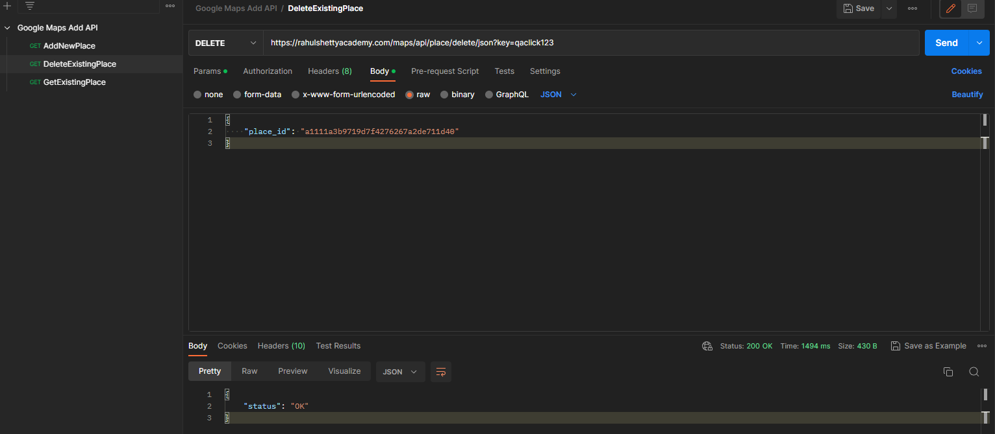

Body:

{

"place_id": "a1111a3b9719d7f4276267a2de711d40"

}

Response:

{

"status": "OK"

}

1. **Get existing place details from Server**

Added a new place. PlaceId = 3408cfe0fb1b6d335d55a39ce2194cd7

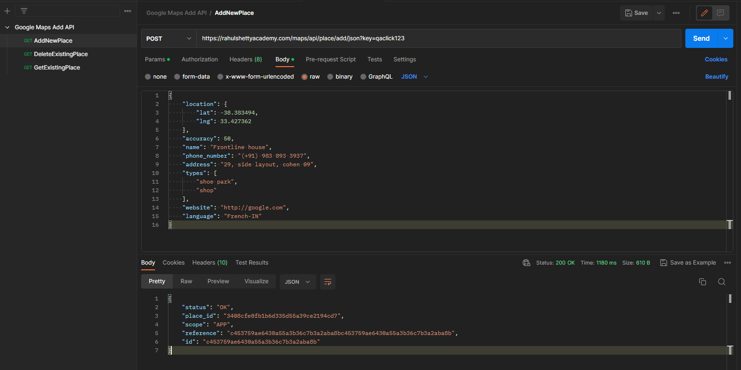

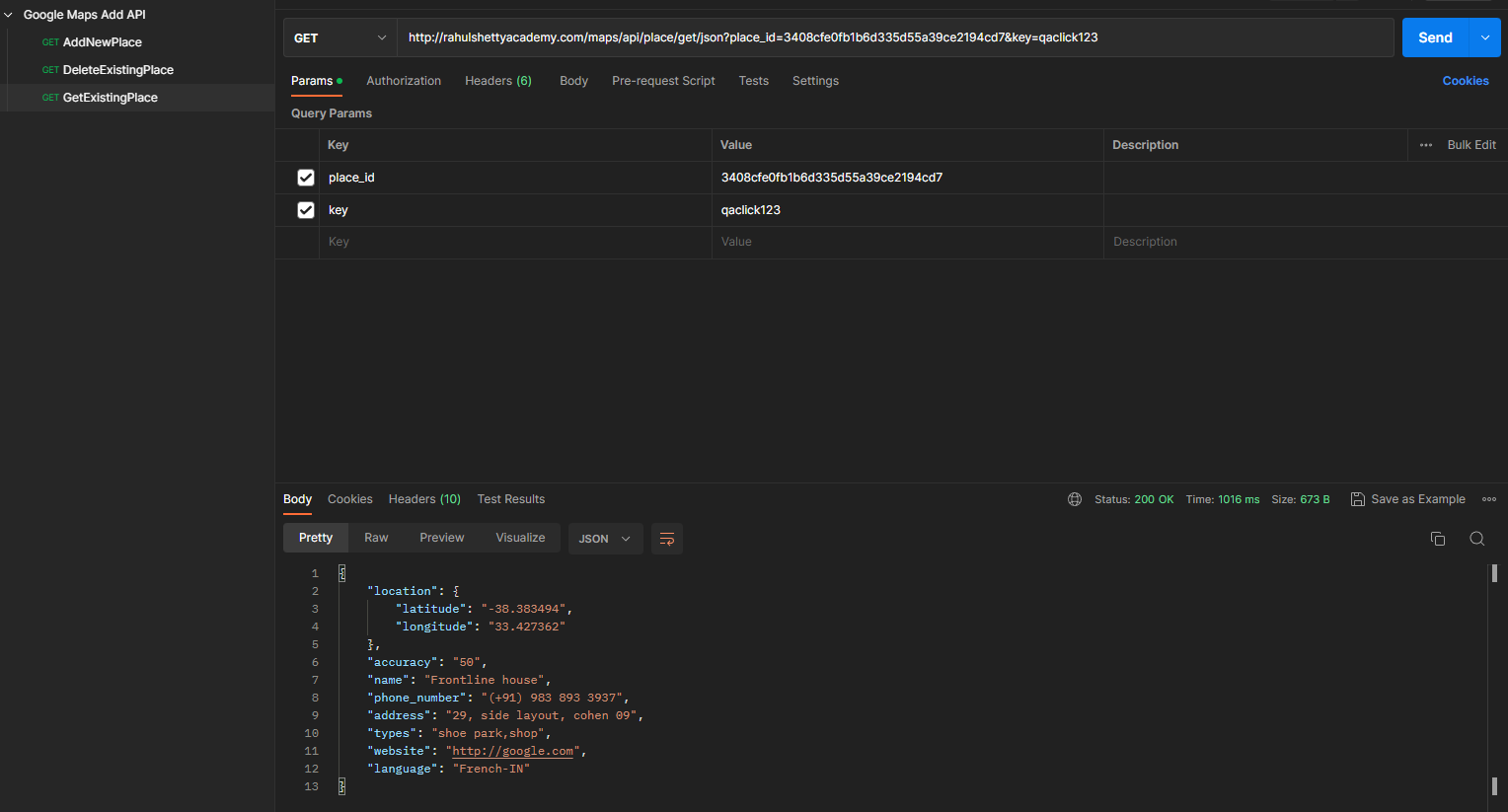

Request url: <http://rahulshettyacademy.com/maps/api/place/get/json?place_id=3408cfe0fb1b6d335d55a39ce2194cd7&key=qaclick123>

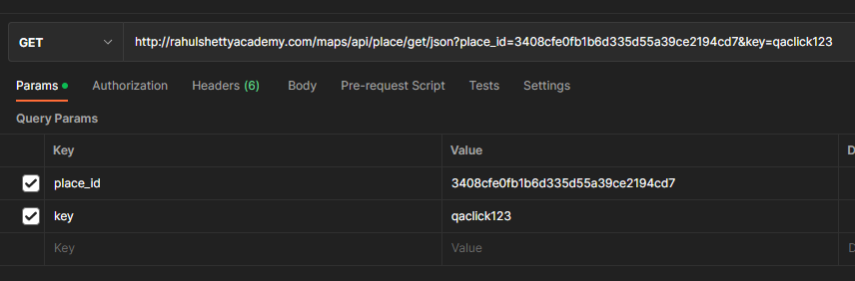

Response:

{

"location": {

"latitude": "-38.383494",

"longitude": "33.427362"

},

"accuracy": "50",

"name": "Frontline house",

"phone_number": "(+91) 983 893 3937",

"address": "29, side layout, cohen 09",

"types": "shoe park,shop",

"website": "http://google.com",

"language": "French-IN"

}

1. **Update existing place in Server with new values**

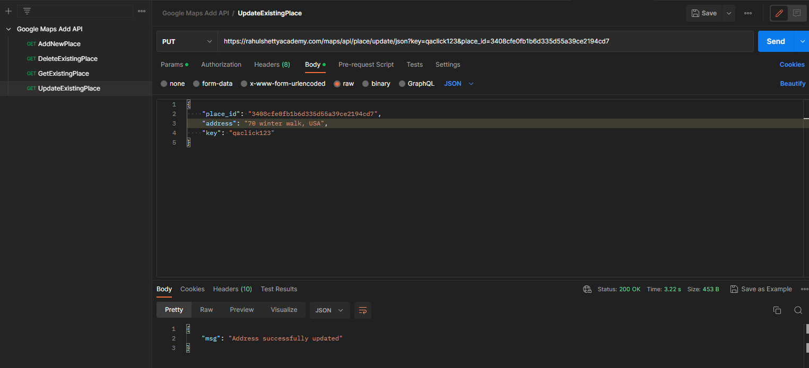

Request url: <https://rahulshettyacademy.com/maps/api/place/update/json?key=qaclick123&place_id=3408cfe0fb1b6d335d55a39ce2194cd7>

Body:

{

"place_id": "3408cfe0fb1b6d335d55a39ce2194cd7",

"address": "70 winter walk, USA",

"key": "qaclick123"

}

Response:

{

"msg": "Address successfully updated"

}

Get:

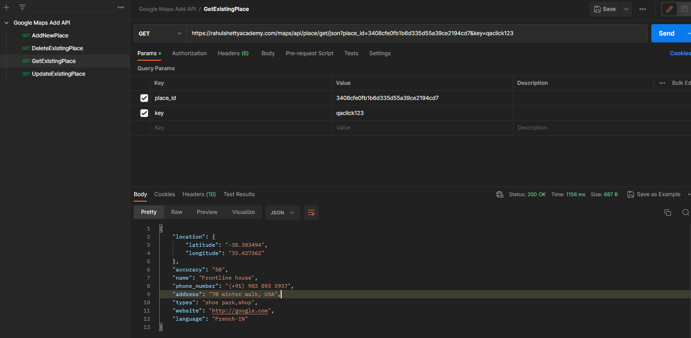

Response:

{

"location": {

"latitude": "-38.383494",

"longitude": "33.427362"

},

"accuracy": "50",

"name": "Frontline house",

"phone_number": "(+91) 983 893 3937",

"address": "70 winter walk, USA",

"types": "shoe park,shop",

"website": "http://google.com",

"language": "French-IN"

}